SIMATS ENGINEERING
CO2 - ASSESSMENT TOOL 2
Scenario-Based Questions
COURSE NAME: Deep Learning | COURSE CODE: | MLA04
Faculty : Dr. Arul Raj A.M | Slot :

COURSE OUTCOME COVERED
CO 2:Students will be able to apply supervised learning algorithms such as linear regression, classification models, decision trees, neural networks, support vector machines, and ensemble methods to solve real-world prediction and classification problems. They will gain the ability to select appropriate models, train them using datasets, and evaluate their performance. Students will also understand the strengths and limitations of different supervised learning approaches.(BTL-4)
Name of the Student | Uppu Sye Kumar
Reg. No | 192325121
GitHub Link | https://github.com/syekumar/MLA0405-Deep-Learning

CO Weightage : 15%
Assessment Tool Weightage: 40%
Duration: 90 minutes

Marks: 25
Code of Conduct:
I Uppu Sye Kumar/192325121 (Name / Reg No) certify that this submission is my original work and that I have adhered to the guidelines specified for this assessment.
I understand that any violation of academic integrity rules will result in disciplinary action.
Signature of the student: U.SyeKumar Name of the student:Uppu Sye Kumar

Scenario-Based Questions
CO-AT2
QUESTIONS: 05 Total Marks:25

Unsupervised Training of Neural Networks, Auto Encoders
A hospital wants to identify abnormal ECG patterns from thousands of unlabeled records. Which deep learning technique from the syllabus would you recommend? Justify your choice and explain the workflow.
- Unsupervised Training of Neural Networks – Autoencoders
Scenario
A hospital wants to identify abnormal ECG (Electrocardiogram) patterns from thousands of unlabeled patient records.
Recommended Technique
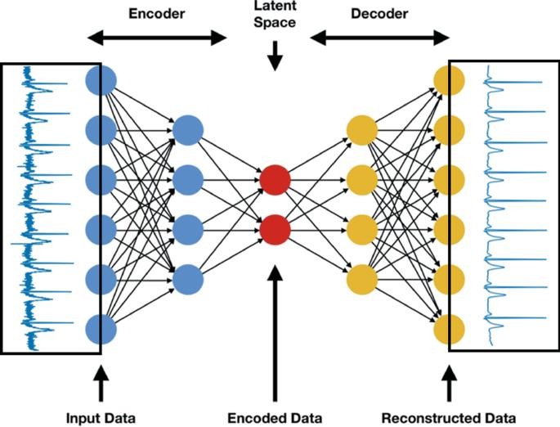
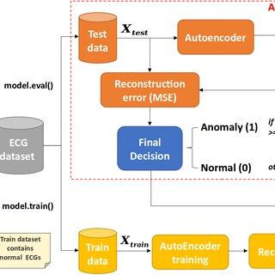
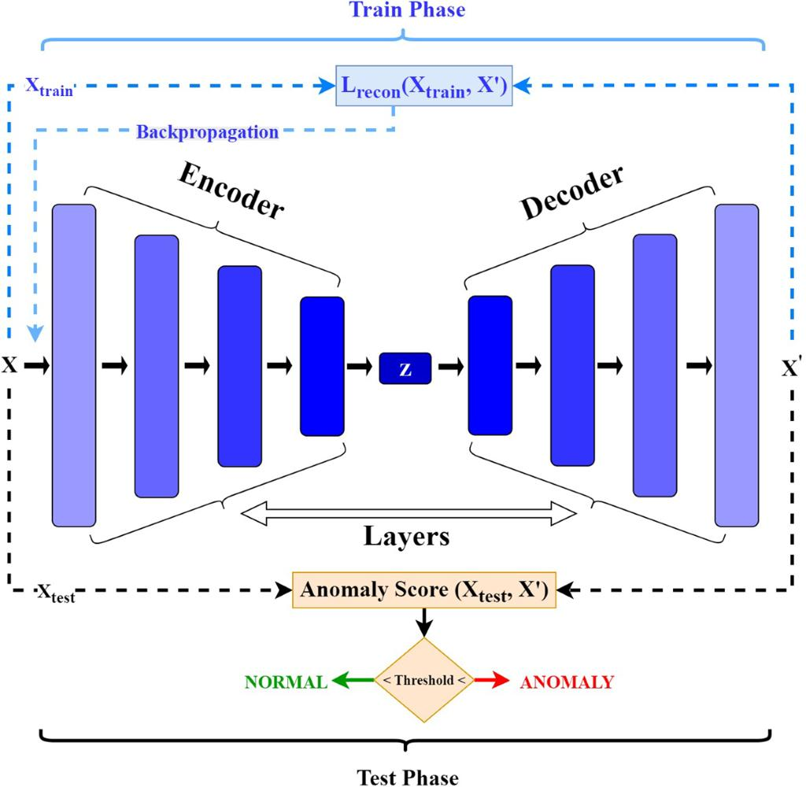

5 Autoencoder (Unsupervised Neural Network)
Why Autoencoder?
Hospitals usually possess a huge amount of ECG data but very little labeled abnormal data because doctors must manually annotate each ECG.
Autoencoders learn the normal ECG patterns without requiring labels.
When an abnormal ECG is given, the reconstruction error becomes high, indicating an anomaly.
Workflow
ECG Dataset
│
▼
Preprocessing
(Normalization, Noise Removal)
│
▼
Encoder
(Compress ECG Features)
│
▼
Latent Representation
(Bottleneck Layer)
│
▼
Decoder
(Reconstruct ECG Signal)
│
▼
Compare Input & Output
│
▼
Reconstruction Error
│
├── Low Error → Normal ECG
│
└── High Error → Abnormal ECG

Step-by-Step Explanation
Step 1: Data Collection
Thousands of ECG signals are collected.
↓
Step 2: Data Preprocessing
- Remove noise
- Normalize signals
- Segment heartbeats
↓
Step 3: Encoder
The encoder compresses the ECG waveform into important features.
Example:
500 Features
↓
64 Features
↓
16 Features
Only essential information is preserved.
↓
Step 4: Bottleneck Layer
Stores compact representation.
↓
Step 5: Decoder
Attempts to reconstruct the original ECG.
↓
Step 6: Reconstruction Error
Difference between:
Original ECG
and
Reconstructed ECG
Normal ECG
↓
Small Error
Abnormal ECG
↓
Large Error

Advantages
- No labeled data required.
- Learns hidden ECG patterns.
- Detects rare diseases.
- Reduces manual workload.
- High anomaly detection accuracy.

Applications
- Arrhythmia detection
- Heart attack prediction
- Remote patient monitoring
- ICU monitoring

Auto Encoders, Representation Learning
A retail company wants to reduce the dimensionality of customer purchase data before performing customer segmentation. Explain how an autoencoder can be used to solve this problem.
- Autoencoders – Customer Purchase Data Dimensionality Reduction
Scenario
A retail company wants to reduce thousands of purchase-related features before customer segmentation.

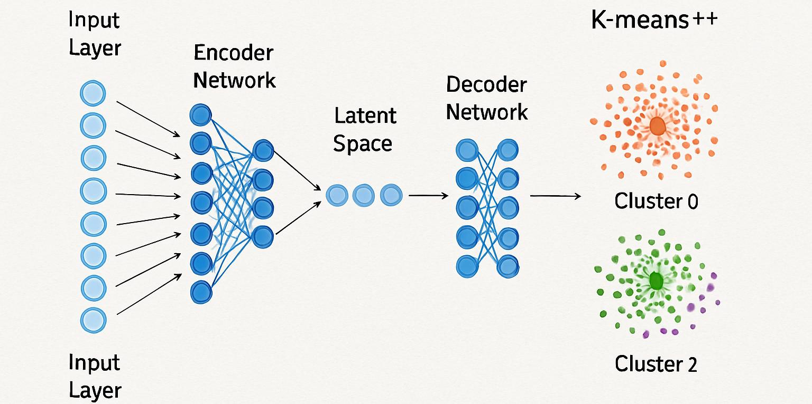
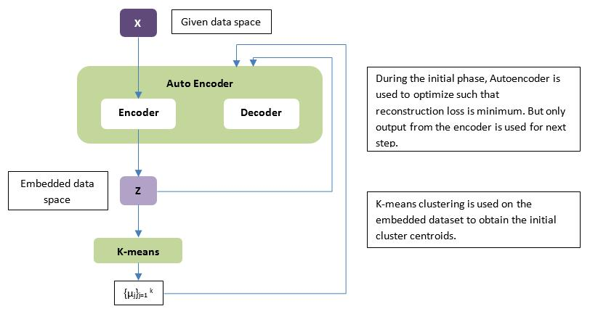
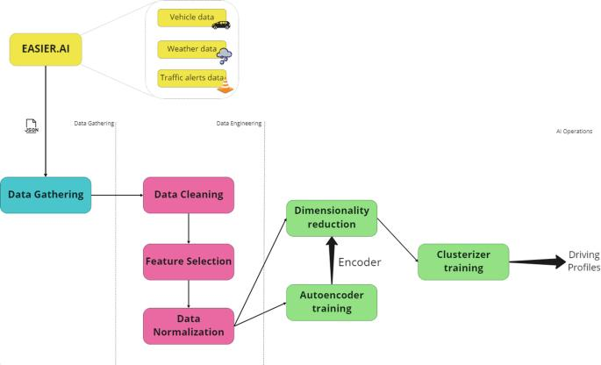
Solution
Use an Autoencoder for Representation Learning.
Instead of manually selecting features,
the neural network automatically learns important customer characteristics.
Workflow
Customer Purchase Data
(1000 Features)
↓
Encoder
↓
Compressed Features
(50 Features)
↓
Decoder
↓
Reconstructed Data
↓
Use 50 Features
↓
K-Means Clustering
↓
Customer Segments

Explanation
Input
Customer information
- Age
- Income
- Purchased Products
- Payment Method
- Visits
- Discounts Used
↓
1000 Features
↓
Encoder
Compresses into
1000
↓
500
↓
100
↓
50
↓
Latent Space
Contains only useful information.
↓
Decoder
Reconstructs original purchases.
↓
Use only compressed representation.
↓
Customer Segmentation
Apply
- K-Means
- Hierarchical Clustering
- DBSCAN
Benefits
✔ Faster clustering
✔ Less storage
✔ Removes redundant features
✔ Better visualization
✔ Improved customer targeting

Applications
- Customer segmentation
- Product recommendation
- Fraud detection
- Sales forecasting

Width and Depth of Neural Networks, Activation Functions
A facial recognition system performs poorly when trained using a shallow neural network. Recommend architectural changes involving network depth and activation functions.
Width and Depth of Neural Networks & Activation Functions
Scenario
A facial recognition system performs poorly using a shallow neural network.

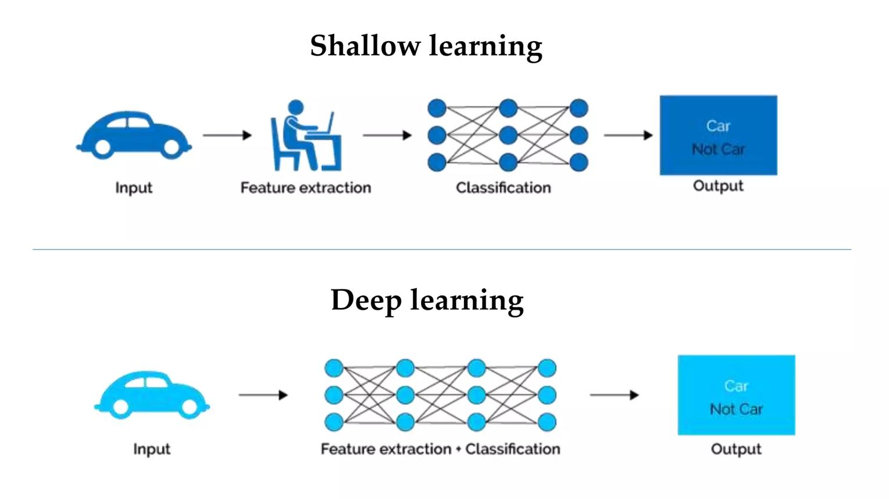
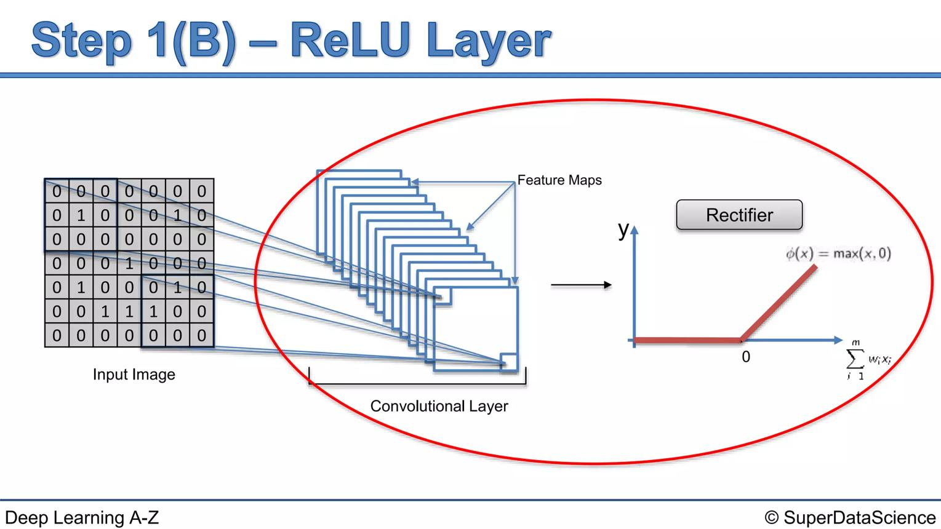
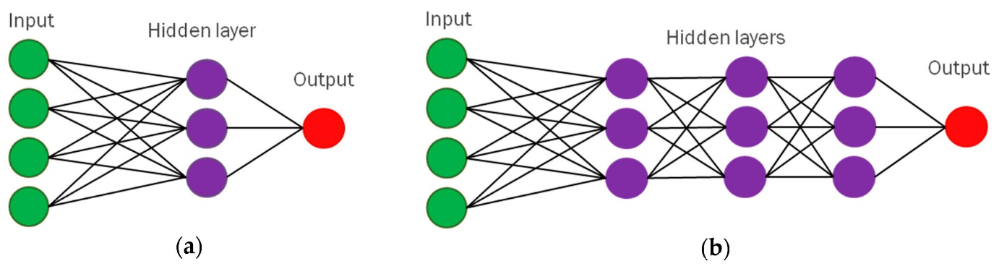
6
Recommended Changes
Increase
- Network Depth
- Number of Hidden Layers
Use better activation functions.

Current Network
Input

↓
Hidden Layer
↓
Output
Problem
Cannot learn complex facial features.
Improved Network
Image
↓
Conv Layer
↓
Conv Layer
↓
Pooling
↓
Conv Layer
↓
Fully Connected
↓
Softmax

Activation Functions
ReLU
f(x)=max(0,x)
Advantages
- Faster training
- Solves vanishing gradient
- Sparse activation
Leaky ReLU
f(x)=x
if x>0
0.01x otherwise
Avoids dead neurons.

Softmax
Used in output layer.
Converts outputs into probabilities.

Why Increase Depth?
Deep layers learn
Layer 1
Edges
↓
Layer 2
Eyes
↓
Layer 3
Nose
↓
Layer 4
Entire Face

Benefits
- Better feature extraction
- Higher accuracy
- Learns complex patterns
- Robust against lighting variations

Applications
- Face Unlock
- Attendance Systems
- Airport Security
- Criminal Identification

Restricted Boltzmann Machines (RBMs), Unsupervised Training of Neural Networks
A streaming service wants to recommend movies to users based on their viewing history without using labeled data. Explain how RBMs can be applied to build the recommendation engine.
- Restricted Boltzmann Machines (RBMs)
Scenario
A streaming platform wants to recommend movies using unlabeled viewing history.

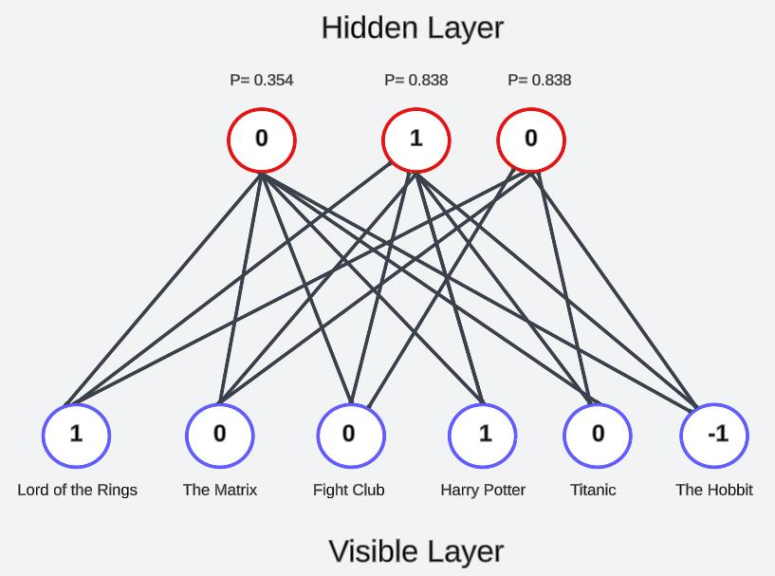
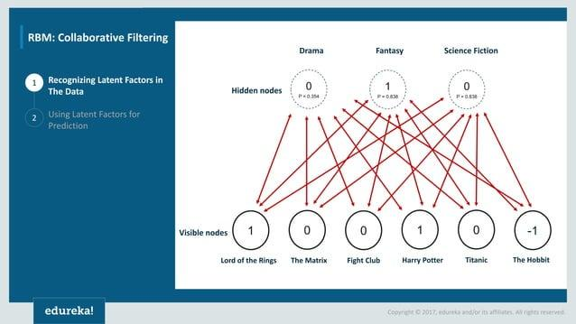
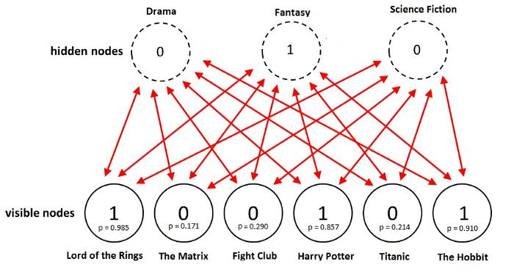
Solution
Use a Restricted Boltzmann Machine (RBM).
RBM learns hidden relationships between users and movies.

Architecture
Visible Layer (User Ratings)
Movie1,Movie2,Movie3,Movie4
↓
Hidden Layer
Preference 1,Preference 2,Preference 3
↓
Predicted Ratings

Workflow
User watches movies.
↓
Viewing history stored.
↓
RBM learns hidden preferences.
↓
Predict unseen movie ratings.
↓
Recommend highest-rated movies.

Example
User watched
- Avengers
- Iron Man
- Thor
RBM learns
↓
User likes
"Marvel Action"
Recommend
- Captain America
- Doctor Strange
- Guardians of the Galaxy
Advantages
- Works without labeled data.
- Learns hidden preferences.
- Handles sparse data.
- Improves recommendation quality.
Applications
- Netflix
- Amazon Prime

Deep Learning Applications, Representation Learning
A manufacturing company wants to detect defective products from sensor readings collected every second. Design a deep learning solution using concepts from representation learning and neural networks.
- Representation Learning – Manufacturing Defect Detection
- Scenario
A manufacturing company collects sensor readings every second and wants to detect defective products.

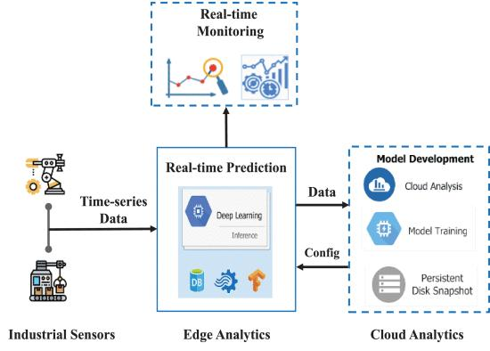
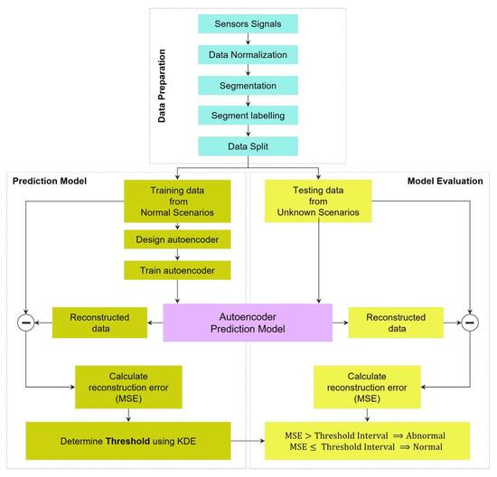
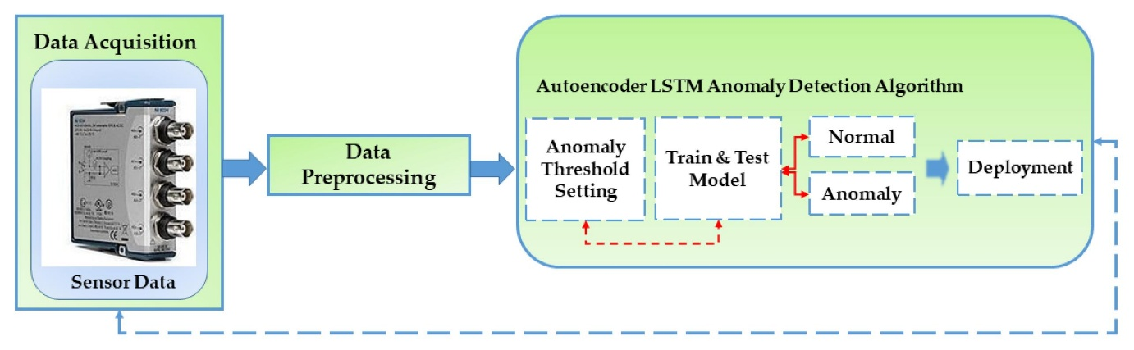
4
Proposed Deep Learning Solution
Use
Representation Learning + Autoencoder + Neural Network
Workflow
Sensor Data
↓
Preprocessing
↓
Autoencoder
↓
Compressed Features
↓
Neural Network Classifier
↓
Prediction
↓
Normal Product
or
Defective Product

Detailed Steps
Step 1
Collect sensor readings
- Temperature
- Pressure
- Vibration
- Speed
- Voltage
↓
Step 2
Clean missing values.
Normalize data.
↓
Step 3
Representation Learning
Autoencoder extracts important hidden features.
↓
Step 4
Neural Network
Uses extracted features.
Learns defect patterns.
↓
Step 5
Output
Normal
or
Defective

Advantages
- Automatic feature extraction
- Early defect detection
- Reduced production loss
- Real-time monitoring
- Predictive maintenance support

Applications
- Smart factories
- Automobile manufacturing
- Electronics production
- Steel plants
- Pharmaceutical manufacturing

RUBRICS FOR CALCULATION:
Criteria | Weightage | Level 4 –  Exemplary | Level 3 –  Proficient | Level 2 –  Developing | Level 1 –  Beginning
Concept  Identification | 25% | Identifies all key concepts from literature accurately and comprehensively | Identifies most key concepts with minor omissions | Identifies limited concepts; some are irrelevant or missing | Fails to identify essential concepts

Linkages | 25% | Establishes clear, meaningful, and accurate relationships between concepts | Shows correct relationships with minor gaps | Relationships are weak, unclear, or partially incorrect | No meaningful relationships established
Organization | 20% | Concepts are wellstructured hierarchically with logical flow and grouping | Mostly organized with minor structural issues | Some  organization but lacks clear hierarchy | No logical organization or structure
Integration of  Literature | 20% | Integrates multiple studies effectively to show connections and comparisons | Shows some  integration of literature | Limited integration; mostly isolated concepts | No  integration of literature evidence
Clarity | 10% | Concept map is clear, neat, visually structured, and easy to interpret | Generally clear with minor readability issues | Clarity is reduced; difficult to interpret in parts | Poorly presented and hard to understand

